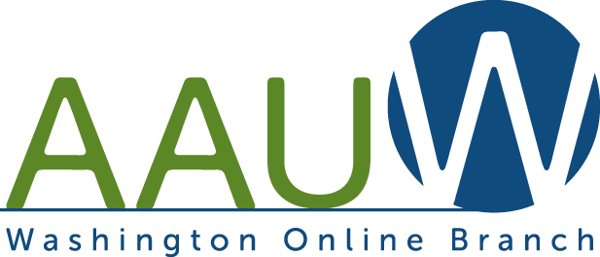
AAUW WA Online Branch
Annual Meeting
March 26. 2022 10:30 AM
Via Zoom

Financial & Membership Report

Finance - As of 3/14/2022
Checking $1178.07
Savings $500
Note: need to maintain $500 balance in each account
2/20 Program expense for 2/17 $80 (Speakers Gifts)

Membership
2020-21: 23 Members Includes 2 life members
2021-22: 33 Members Includes 2 life members
Note: AAUW’s Member Services Database (MSD) [Community Hub] will NOT be operational until end of March/early April so dues renewal notices for 2022-23 will not be sent until April.

New Members for 2021-22 (total 12)
6/12 Tobi Balma 18403 Winslow Pl Cerritos, CA 90703-6035 (562) 305-0285 aauw.tobi@gmail.com
8/3 Yvonne Berliner PO Box 93 (604 N 7th St.) Garfield, WA (509) 338-7047
ygberliner@gmail.com
5/28 Catherine Chambers 1510 N Forest St UNIT 410, Bellingham, WA
cathecham@gmail.com
4/17 Leslee Eicher 3302 N Narrows Dr Tacoma, WA (253) 888-3997
eicher.leslee@gmail.com
9/24 Melissa Johnsen PO Box 758, Kirkland, WA 98083 949-689-0704
Johnsen.melissa54@gmail.com
5/28 Robin Lynn Kagan 1025 12th St, Bellingham, WA (H)(360) 676-5205
(W)(360) 303-0479 raquel_playz@comcast.net
10/13 Marianne North 19230 Forest Park Dr NE, Apt L137, Lake Forest Park, WA 98155
206-822-7810 mariannenorth@yahoo.com
8/25 Susan Richart 2714E Quarry Browns Lake Rd, Chewelah, WA 99109
H (509) 935-8857 srichart4@gmail.com
5/3 Karen Rosebaugh 16520 North Road H-201, Bothell, WA (425) 501-5613
karenrosebaugh201@comcast.net
6/23 Mardy Stevens 245 NE 4th St, Gresham, OR 97030-7424 (503) 669-0452 mardy.stevens@frontier.com
6/5 Gail Swain 2338 Galloway Ave, Bishop, CA (760-920-7497
gailrmswain@gmail.com
6/4 Beverly Van Citters 3500 Las Palmas Ave, Glendale, CA (H)(818) 957-4383
(W)(818) 406-3453 bvancitters@gmail.com
2 Members from 2020-21 chose NOT to rejoin

